|  |  |
| --- | --- |
|  | **KD04203: SPECIAL TOPICS IN COMPUTER SCIENCE**  Semester 1 2022/2023  Faculty of Computing and Informatics |
| **Quiz 1** | |

# Name : LO GUAN SIANG

# Matrix No : BI19110220

**Question 1. (5 marks)**

What is an Agent? Describe in your own words.

Ans:

An agent is a computer system that exists in a given environment and can act autonomously in that environment to achieve its delegated goals. An Agent constantly perceives, thinks, and acts through the actuator's sensors and effectors with the environment. The common agent has the attributes such as autonomy, knowledge-level communication ability, temporal continuity, adaptability, mobility and personality.

# Question 2. (8 marks)

Draw a block diagram showing the relation between Agent and Environment. Describe the block diagram with your own words.

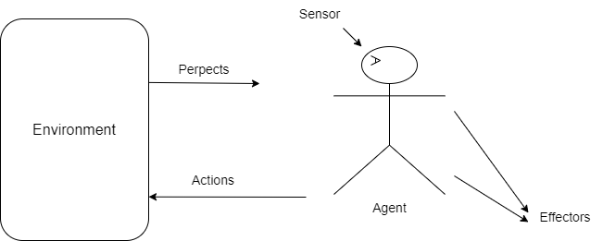

Ans:

The agent can perceive its environment through sensors and act upon that environment through effectors. An agent observes its environment through sensors. Effectors are the devices which affect the environment. In the block diagram, the agent is human. A human agent has eyes that work for sensors and hands and legs for effectors.

# Question 3. (10 marks)

An intelligent agent is a computer system capable of flexible autonomous action in some environment. What are the three basic characteristic (or properties) of an intelligent agent? Describe each of the characteristic.

Ans:

-An intelligent agent is a computer system capable of flexible, autonomous action in some environment. An intelligent agent's three basic characteristics are reactivity, proactivity and social ability.

-Reactivity means an intelligent agent can maintain an ongoing interaction with its environment and respond to changes in it.

-Proactivity means the intelligent agents have the goal behaviour, take the initiative to achieve the goals and are not driven solely by events.

-The intelligent agents' social ability means the ability to interact with other agents and possibly humans via cooperation, coordination and negotiation.

# Question 4. (5 marks)

Describe what an object is. Explain with your own words

Ans:

A collection of attributes and method calls makes up an object. Simulation is the fundamental concept behind object-oriented programming. Programming should simulate the states and behaviours of real-world objects. The concept of class is essential in object-oriented programming. A class can be assumed to be a cookie cutter, as it can produce numerous cookies with the same shape. A mammal class, for instance, may contain many distinct objects, such as humans, lions, deer, and cows. An object can encapsulate some state, communicate via message passing and possess methods corresponding to operations that can be performed on this state.

# Question 5. (6 marks)

Describe three differences between agent and object.

Ans:

-Agents are autonomous where the object is not autonomous. Agents exemplify a stronger sense of autonomy than objects in that they decide independently whether to carry out an action requested by another agent where the object cannot.

-Agents are smart where the object is not.

The agent is capable of flexible reactive, pro-active and social behaviour where the object does not have this behaviour.

-Agents are active where the object is not.

Each agent is assumed to have at least one thread of active control in a multi-agent, inherently multi-threaded system.